**General Electric**

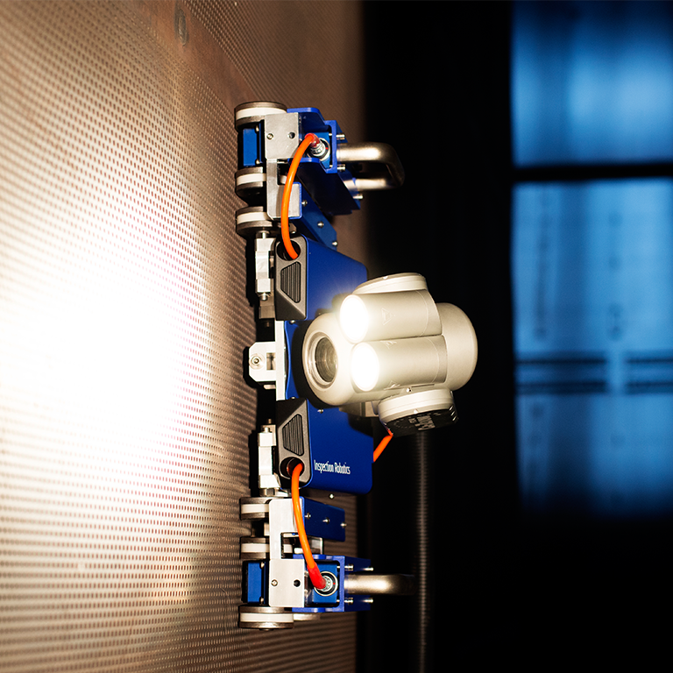

General Electric is a company that specializes in a broad selection of applications and has expanded its reach into robotics. GE’s goal by this expansion is to develop products that assist their oil & gas customers directly, by making inspection and maintenance of their products an easier process. While GE’s actual technologies differ from our system, they can still be researched to improve different aspects of our product.

General electric produced several products based on what they call the FAST Platform in addition to offering custom product development for special applications. Some features of the FAST Platform and modifications include:

* Modular design for changing loadouts
* Cameras mounted for visual inspection
* Ultrasonic sensors for surface inspection
* Brushes for cleaning applications (on specific models)
* Small size (approximately 6” tall)

While there are many attachments to the FAST Platform, it’s use is limited to the oil & gas industry. The FAST Platform is also a teleoperated system, meaning that a human operator is necessary to use the device as the robots cannot map and inspect an area on their own. Often, it is necessary in industry to reduce need for human operators in order to better allocate resources and reduce overall costs.

The Multi-Robot SLAM system that is to be developed for L3 Technologies is an entirely different system from GE’s FAST Platform. As a multi-robot system, it either must have multiple human operators, or must be fully autonomous. If the robot system cannot operate on its own, then each robot would need an operator in order to function. This being said, the L3 robots must be equipped with an entirely different system of sensors such as LiDAR and 3D depth cameras. Like the FAST Platform’s ultrasonic sensors, the L3 sensors will record images of environment depths. LiDAR is capable of producing constant 2D maps of the surroundings which allow for autonomous navigation. 3D depth cameras produce 3D images of small observable windows, allowing for slower analysis of specific objects within the environment. Combining these two technologies allows for robots capable of navigating and identifying features within the working environment. While the technologies used are distinctly different, the purpose of these robot systems is practically the same: to inspect features with limited human intervention.

**Google**

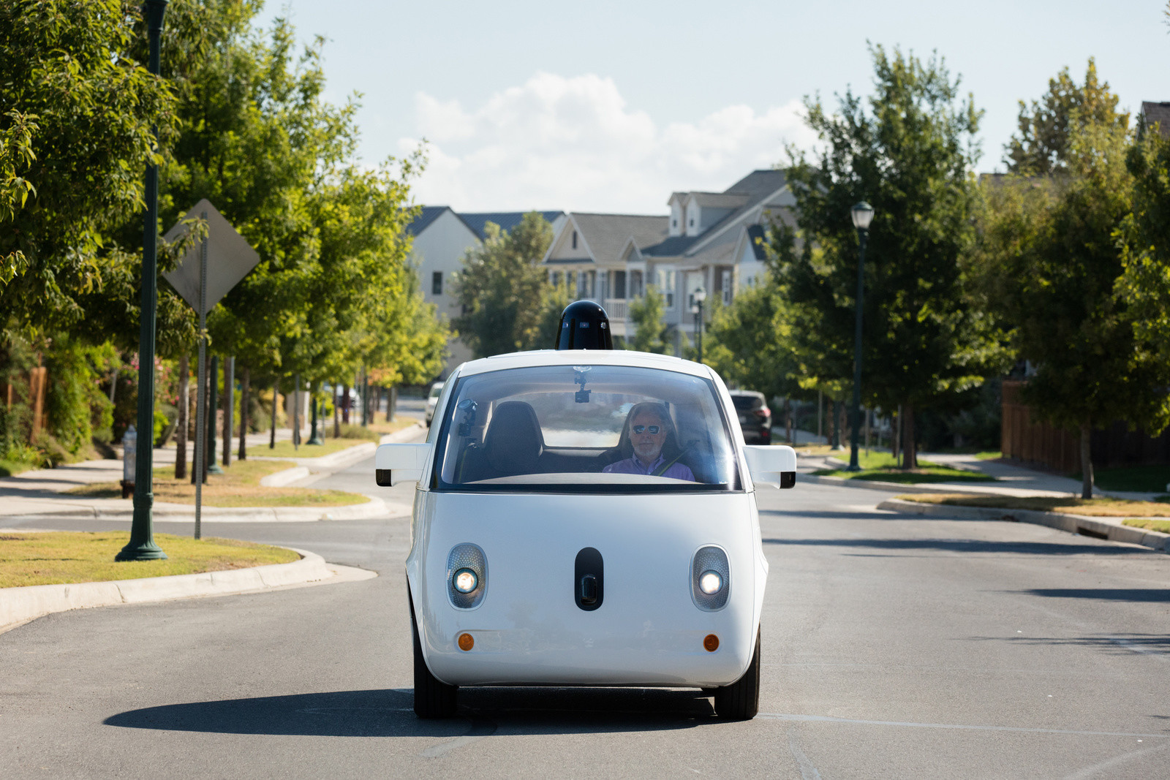

Google is a giant in web searching, data analysis, and much more. The company is also developing devices within the field of robotics, most notably the Waymo platform. Waymo is a vehicle intended to make driving safer and more accessible by taking away human error and making it fully autonomous. The intent of Waymo is very different from that of the FAST Platform or the Multi-Robot SLAM system, but the technologies still align. Google’s Waymo utilizes LiDAR to create immediate maps of the environment for obstacle avoidance, trajectory calculation, and path planning. It also utilizes several cameras located at various points on the vehicle to observe 360 degrees of images at any point in time. The images can be processed in the vehicle’s computer to identify traffic signs, text, and objects that may have not been observed by the LiDAR. Lastly, Waymo uses GPS, Magnetometers, and more for overall global localization.

The Multi-Robot SLAM system does not need all of the sensors included in Waymo to operate as it has a much simpler purpose with less risk. Global localizing equipment is not necessary as the local coordinate frame of the vessel on which the robot is exploring is constantly changing. In addition, GPS is practically useless in a small setting. Therefore, the multi-robot system must use LiDAR and depth cameras exclusively to localize and collect data. In addition, multiple cameras are not needed for the system as each robot operates at low speeds and uses image processing as a secondary feature. However, the single camera that will be present on each of these robots will serve a similar purpose, identifying objects based on characteristics (defined by machine learning algorithms) and identifying other robots as well. The LiDAR will serve the same purpose, mapping the environment and using the developed maps to determine necessary actions to avoid objects and explore unknown areas. In addition, orientation and location estimation will likely be calculated based on odometry data (how many times the wheels spin), replacing the function that GPS and similar sensors normally have in large-scale systems. Overall, the differences in Waymo and the L3 Multi-Robot system are outlined as follows:

* L3 uses odometry to orient rather than GPS and magnetometers meaning they can operate on vessels
* 2D LiDARis used with a single 3D depth camera rather than Waymo’s several cameras and 3D LiDAR, simplified for this application
* Human override will be possible with the L3 system as opposed to the Waymo system
* Machine learning algorithms in the L3 system are specialized for naval application
* The L3 system utilizes multiple robots for navigation while the purpose of Waymo is for a single device to navigate on its own

While the overall goals of Waymo and the Multi-Robot SLAM system are not aligned, the technologies that govern their operation are inherently similar. However, the Multi-Robot system is more specialized and compact for the purpose of inspecting ships and similar environments.

**PureTechnologies**

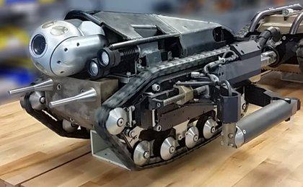

PureTechnologies is a robotics company that designs and manufactures pipeline inspection systems that can be applied to any pipe application. The products include monitoring technology that can detect and locate failures in high-strength steel wire or cable through continuous remote monitoring. The three main applications that this company produces for include oil and gas pipeline, water and wastewater pipelines, and bridges and structures.

Common sensors that are utilized on these pipeline robots include:

* high definition digital pan-tilt-zoom CCTV for live video streaming
* high speed pipe-profiling SONAR for measuring pipeline’s size, shape, and corrosion
* Laser profiling and LIDAR with 3D reporting capabilities to map the area
* Electromagnetic sensors for assessing structural integrity
* Geographic mapping technology to plan out pipeline’s directional analysis

The technology used within this system is capable of performing:

* Short and long-range inspections under various operating conditions
* Within water, wastewater, industrial and power applications
* With different robotic track feet depending on the pipe type and diameter
* Without manual aid for entry and exit from the water or pipeline
* With a maximum speed to allow for advanced inspection during time critical shutdowns
* With immediate data results due to portability and three integrated monitors

Some downfalls of this system include:

* Size and ability to navigate narrow areas
* A manual user is needed to overlook the camera feed
* Robots work individually causing longer inspection time and a higher risk of lost information

**Strahl LLC**

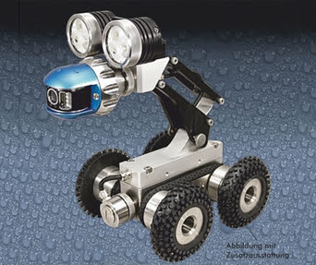

Strahl LLC is a company that produces and manufactures pipe crawling robots that include a wide spectrum of functions. The company offers a complete product line of boroscopes, endoscopes, inspection cameras, fiberscopes, and sewer cameras. Applications of this technology range from aviation, power generation, and the automotive industry to security, welding, and sewer and wastewater inspection. These systems are primarily used to maintain safety standards, to prevent equipment failures, to carry out repairs, and to detect wear and tear. By inspecting these systems and staying on top of the maintenance of these systems, unnecessary financial losses can be avoided.

Some functionalities that are included on the most recently launched pipe crawler include:

* The ability to inspect pipes up to 150 meter long
* Controllable speeds up to 33 meters per minute
* An operational system has an optional steering function which allows for the system to bypass bends and corners with more ease
* A standard configuration feature of a auto-leveling, pan and tilt camera head and a 120 meter long cable

Some positive aspects of this system that place it above other robot inspection systems include:

* The LCD high definition monitor that protects from scratches and other physical damage done by a metal case
* A full keyboard is also included allowing for text to be entered for notes or naming files
* A camera that can withstand a water pressure up to 50 ft in fresh water and has built in high powered LEDs which provide ample amounts of illumination
* A SD memory card allowing for files to be saved and stored directly onto the system and therefore improving the data portability
* The ability to be adjusted upon request by adding extra wheels, including a camera raiser to keep the camera centered, or including a sonde locator to locate nonmetallic pipe

Possible improvements that could be made to this system include:

* Adding a LiDAR sensor allowing the system to be able to map the area on a primary level. Systems including both a camera and LiDAR allow for a more in depth analysis to be performed.
* Removing the manual observer by having the system autonomously annotate and store the areas of interest. This would save both time and resources.
* Including multiple robots. This system is meant to work individually causing the process to take more time.

**Amazon Robotics/Kiva Systems**

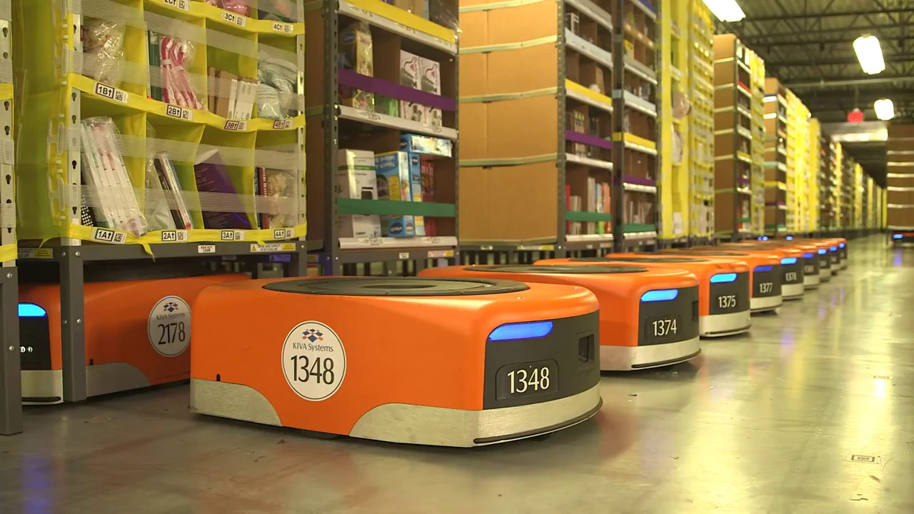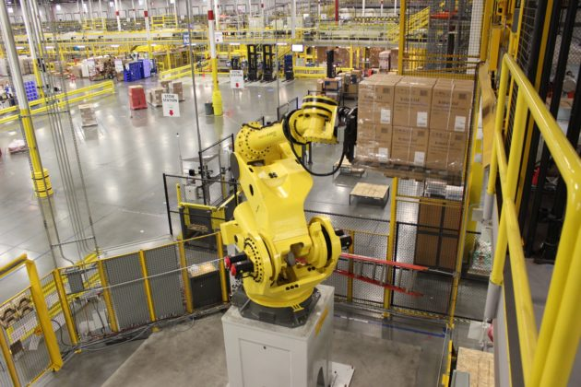

Amazon Robotics was founded with the goal of meeting the demands of customers by providing better solutions. In 2012, Amazon acquired Kiva Systems, a small start-up robotics company. Currently, Amazon Robotics is placing robots in the operations field to transform how operations is run. Amazon Robotics is Amazon’s largest research and develop organization on the east coast and is continuing to grow. Amazon Robotics is dedicated to improving their technologies. They are headquartered near Boston and have developed with many partners to develop the next cutting edge technology. One initiative of Amazon Robotics has been to automate operations using various robotic technologies to utilize in fulfillment center. Some of the technologies that they research include the following:

* autonomous mobile robots
* control software
* depth sensing
* object recognition

Today, Amazon alone is using over 30,000 robots throughout their various facilities. Previously Amazon was selling these Kiva robots, later named Amazon robots, but they are now only using them for their internal use. The robots acquired by Amazon were first used in late 2014 to help with the efficiency of inventory management. Before implementing the robots in their processes, the “click to ship” cycle was close to 60-75 minutes. This time was due to the fact that an employee had to manually search through all of the products, pick the correct one, pack it and ship it. With robots, that same sequence of events can happen in close to 15 minutes. Robotic technology has revolutionized the warehouse industry and this can be applied to the project at hand. Similarly, inventory aboard a ship, whether commercial or military, can be monitored, inspected and inventoried more efficiently using robotics. This is what the team is set out to do as the crew aboard a ship is limited. Searching for a specific object, making a general inventory or searching for a suspicious object are all tasks that could be completed mostly autonomously by a network of robots with little human interaction.

*Differences between Amazon Robot and L3 Project:*

|  |  |
| --- | --- |
| **Amazon** | **L3 Project** |
| Many types of robots | Single type of robot |
| Perform many different tasks | Perform one task (merging map data) |
| Don’t merge data | Merge map data |
| Autonomous with centralized computer | Autonomous with human interaction to begin task |
| Navigation help: Markers on floor | Navigation help: None |
| Large in size | Small in size |

While I couldn’t find many specifics on the robots Amazon uses, there are many basic attributes of their system that our team can keep in mind including communicating with the network of robots through a centralized computer and placing markers or QR codes on objects to help the network identify objects. There are also many different types of robots that perform different tasks that could eventually be incorporated into a larger network of robots for future senior design projects if the scope of the project is expanded.

**Simbe Robotics- Tally**

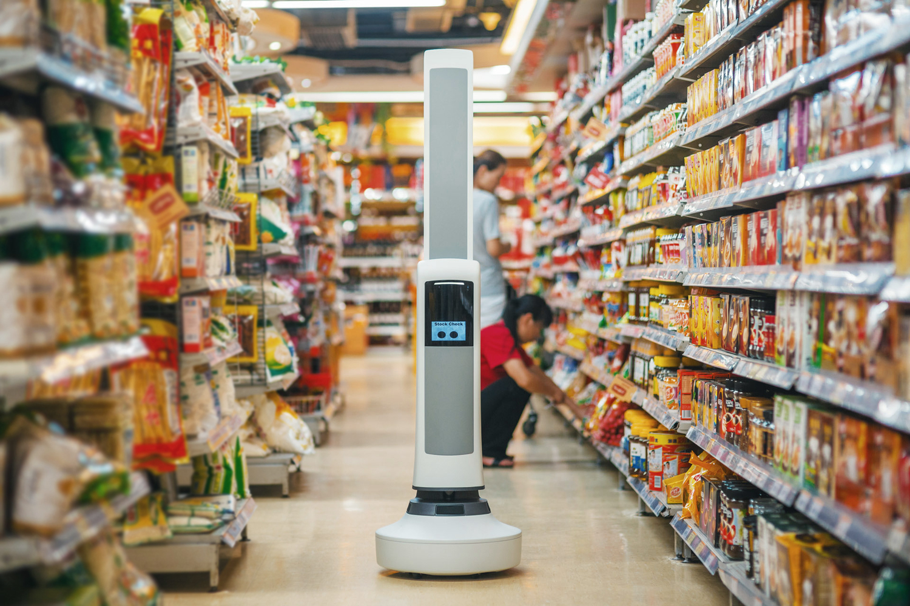

In 2016, Target began testing robots that track inventory on the retail floor, instead of behind the scenes in the stockroom. Target conducted a one week trial at a store in downtown San Francisco with robots from a Silicon Valley startup company called Simbe Robotics. This company created a robot named “Tally” that autonomously moves throughout a stores and scans products. This robot is a relatively tall and skinny robot with a round base. Beside Target, other major companies have also bought Tally and have used them in their stores as well for similar purposes. The following are some of the functions of Tally:

* detect products out of place
* wrongly priced products
* products out of stock
* products low on stock
* Deliver real-time information to computer
* Automatically stops and finds charging dock when low on battery
* Avoids customers and obstacles
* Skips aisle if aisle is packed with customers
* Screen to be “more friendly”

Simbe Robotics markets Tally as “The World’s First Fully Autonomous Shelf Auditing and Analytics Solution”. Each robot is around 30 pounds and only 38 inches tall with an additional extension that allows the robot to scan shelves higher up. The robot navigates using many sensors and cameras on the circular base--these help the robot navigate obstacles and check for shelves that are empty.

The robot created by Simbe Robotics has many features that allows the robot to move and perform their intended task completely autonomous. One of the biggest features that should be kept in consideration for the purposes of this project are that it is completely autonomous and does not need human interaction. In fact, it shies away from human interactions. This could be helpful for the multi robot network because the crew size is limited and other jobs performed by human operators could possibly be of more use than monitoring the system. Having many sensors and the cameras on the base are similar to how the team is proposing to monitor and inspect the internal areas of a ship. The major difference is the different sensors and technology being used. However, the basis for the purposes of the sensors and cameras are very similar. The team could also use this technology and incorporate a camera system similar to the one in Tally so that it would easily avoid obstacles and avoid having to create markings on the floor of the ship.

The size and shape of Tally would be a negative drawback for bringing this product into a location that is not stable 100% of the time. This robot would not be stable aboard a moving ship that could place the robot at an angle that would most likely tip the robot over. Another drawback of the robot is that multiple robots do not seem to communicate with one another. This is a huge drawback and could be an area for large improvement. With multiple robots communicating with each other, they could cover the entire store quicker and without possibly needed a recharge. This improve could drastically change the size of a store or company that would be interested in buying an autonomous inventory tracker.

**Max: KnightScope**

KnightScope is a company specializing in robot security options, they offer few different platforms all based around the same central design and with sensors customized to customer needs. Their robots patrol certain zones designed by GPS and autonomously attempt to discover and categorize threats to the client in that area. These systems are specialized to focus on areas that have good wireless and satellite coverage, level terrain, and easily traversable spaces, and as such are ideally suited to office and metropolitan work. There they have a regular ordered environment where anomalies are easy to detect, analyze, and relevant human authorities are close by.

KnightScope's robots include:

* thermal and visual imagine,
* range finding, gps, and
* a wide range of environmental sensors, which probably include
* various gas, smoke, and gyroscopic sensors.

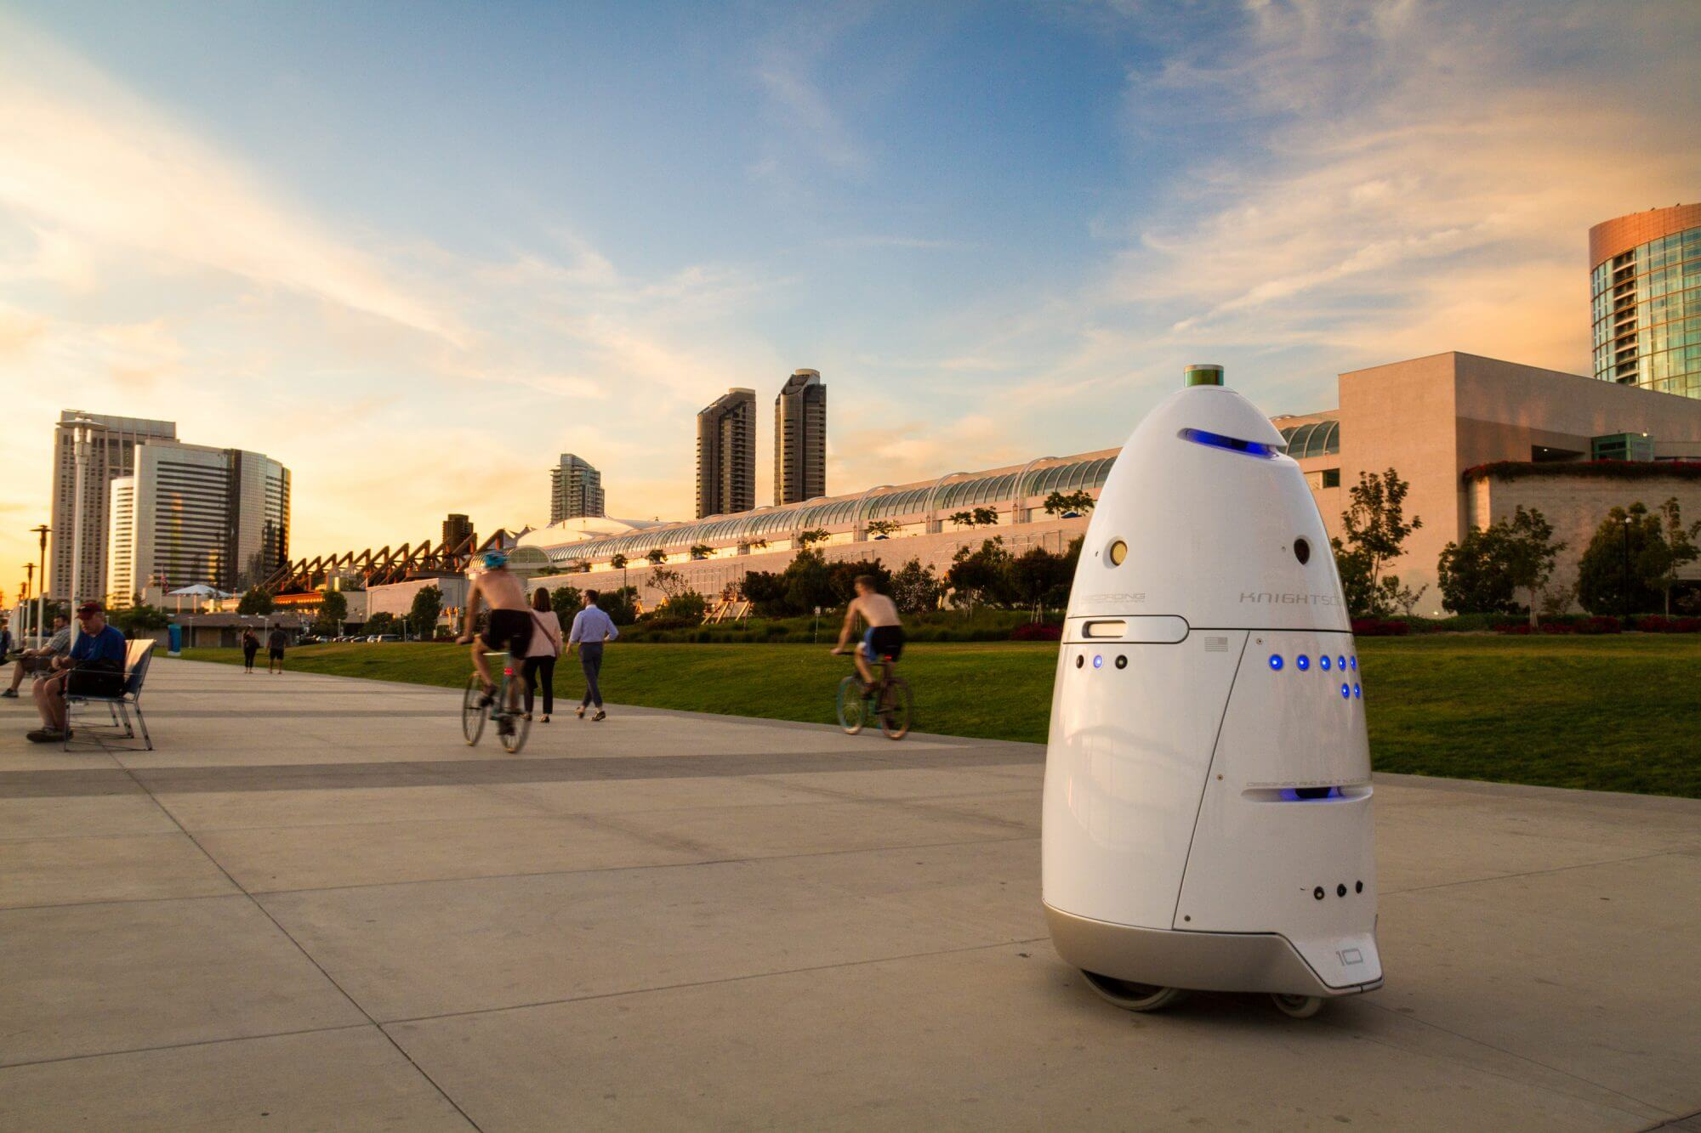

They have a very solid base and have methods of dealing with would be vandals, namely by snapping a picture, alerting the suspect that they have done so, and sounding an alarm both where the platform physically is, and at a control center. The robots also refrain from bothering anyone uninvolved by use of a GPS geofence system, where they can be made to patrol certain paths or roam free in an area that they can function well in. their signature feature is however gun and metal detection, and the ability to alert police with a picture of the suspect and follow them discretely or make further use of the siren they have equipped. The robots can also vocalize instructions in 16 different languages, as well as connect to an operater who can communicate with those nearby.

What separates knightscope is the adaptability to different circumstances the drones have; by bringing human oversight into the mix they can monitor different situations and respond accordingly. They also make a variety of platforms for different types and ranges of terrain, allowing them a fairly large potential market share. The real benefit Knightscope offers isn’t replacement of an existing security system but rather an extremely effective force multiplier, allowing less people to cover a larger area and do so more effectively as robots have a variety of sensing options that humans lack and would be difficult for humans to implement without altering the environment.

Knightscope has a number of weak points however. First and most glaring, they don’t have a prototype capable of all the sensing options they list on their site, with many marked with a “coming soon.” Companies can promise the moon, but they need to be able to actually deliver. Also the geofencing utilized only seems to account for gps coordinates, or may be inaccurate. There are accounts of drones falling into fountains or down steps, or just continuously running into doors while attempting to complete routes. This would be an area that SLaM would definitely beat KnightScope’s approach in. By mapping the terrain dangers such as falls and other difficult environments can be bypassed, since the robot would know that it's approaching a dangerous obstacle and maneuver to avoid it KnightScope has a very solid idea, but the implementation seems to be lacking currently and that is what will ultimately decide their fate as a profitable company.

**Stevens Research**

There are several research projects currently ongoing at Stevens institute of technology that help define the current landscape of SLaM in Robotics. These are designs on the very cutting edge of the industry, utilizing a few different methods. Some examples include LiDAR based SLaM on a mobile JACKAL system, a rugged 4 wheel platform ideal for forest environments. The Turtlebot platform is also used, both in single and multiple robot systems. These focus on 3d depth cameras for navigation instead of a LiDAR system.

These projects all share one aspect, mobile devices that can learn their environments and navigate them accordingly. 3d depth cameras generate a “point cloud” which allows for visualization of solid surfaces in the field of view, as well as the distance to each point. This in turn makes it fairly easy to populate a map with this information creating an easily accessible bank of information. Then the robot only needs to avoid having any distances approaching too close while moving round the room, until every space is mapped in this method. The other strategy is to use 3d lidar to take stock of surroundings. This does not give as much detail and information as a point cloud, as lidar works under a different principle. The information returned is distances to solid objects in a series of concentric circles at different elevations. This requires significantly less processing power than the point cloud to analyze and gives almost as much information. The differentiating factors of this research are as follows:

* it’s ideally positioned to pivot if there is a breakthrough in the field
* or even to make said breakthrough.
* Also as it is research being conducted there is a lot of communication between groups and even with external sources.
* The flexibility and responsiveness clearly separates this form most companies currently in the field.

However there are some issues, namely how a good many of the projects are sponsored and as such are obligated to post results and methods for free or to only certain journals, any developments made will not be easily marketed as prior art will be available and prevent any sort of copyright protections that the inventor may normally enjoy. A second potential issue is that most of the work being done is done to test out specific potential solutions rather than geared towards any sort of ease the end user may want. The platforms give a large degree of freedom with regards to how they function but a significant learning curve will be required to operate them, something that will exclude many potential customers

**Resources**

GE

<http://inspection-robotics.com/fast-rvi/>

Google

<https://waymo.com/>

Amazon Robotics

<http://www.businessinsider.com/amazons-robot-army-has-grown-by-50-2017-1>

Simbe Robotics

<http://www.businessinsider.com/target-testing-iot-robots-in-stores-2016-5>

<https://www.forbes.com/sites/nikkibaird/2017/02/28/robots-in-retail-stores-closer-than-you-think/#634507875d96>

<http://fortune.com/2016/04/28/target-testing-robot-inventory-simbe/>

KnightScope

<http://www.knightscope.com/>

<http://www.knightscope.com/faq/>

Stevens Robust Field Autonomy lab

<http://personal.stevens.edu/~benglot/>

Pure Technologies

<https://www.puretechltd.com/technologies-brands/pure-robotics>